ALLERGAN PARTNER PRIVILEGES DOCUMENTATION

**TEAM-3**

Manoj Kumar

Sumanth N

Raghav Kumar

Anuj Gupta

Snehitha Ramesh

***ALLERGAN PARTNER PRIVILEGES***

***PROJECT DOCUMENTATION***

1. **Home Page**: *For Allergan Partner Privileges.*

**Functionalities:**

* *Home: The page is redirected to the home page.*
* *Login: The page gets redirected to the login page.*

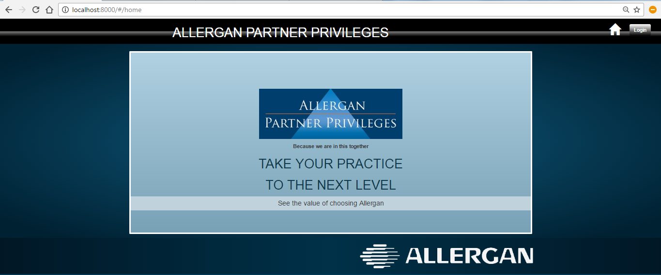

1. **Login Page:** *This page appears on click of the login button on the home page. The user needs to provide the valid credentials in order to successfully login.*

**Functionalities:**

* *Home: The page is redirected to the home page.*
* *Login: The page gets redirected to the login page.*

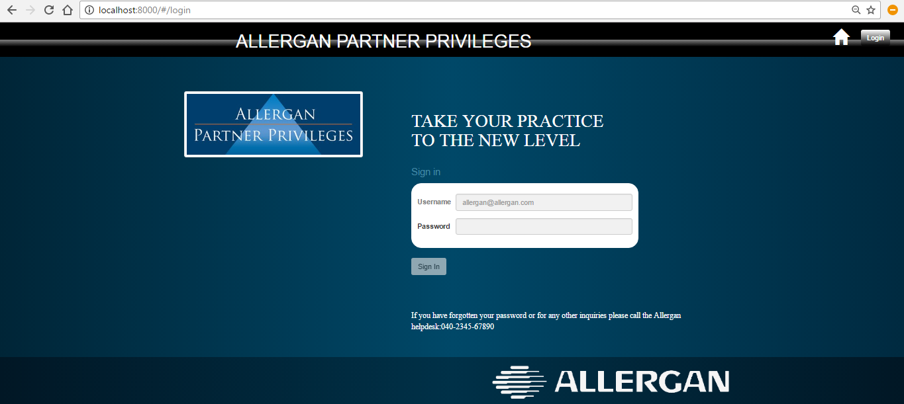

1. **Invalid-Credentials:** *If the given credentials by the user are invalid then a message is displayed saying “invalid credentials’.*

Functionalities:

* *Home: The page is redirected to the home page.*
* *Login: The page gets redirected to the login page.*

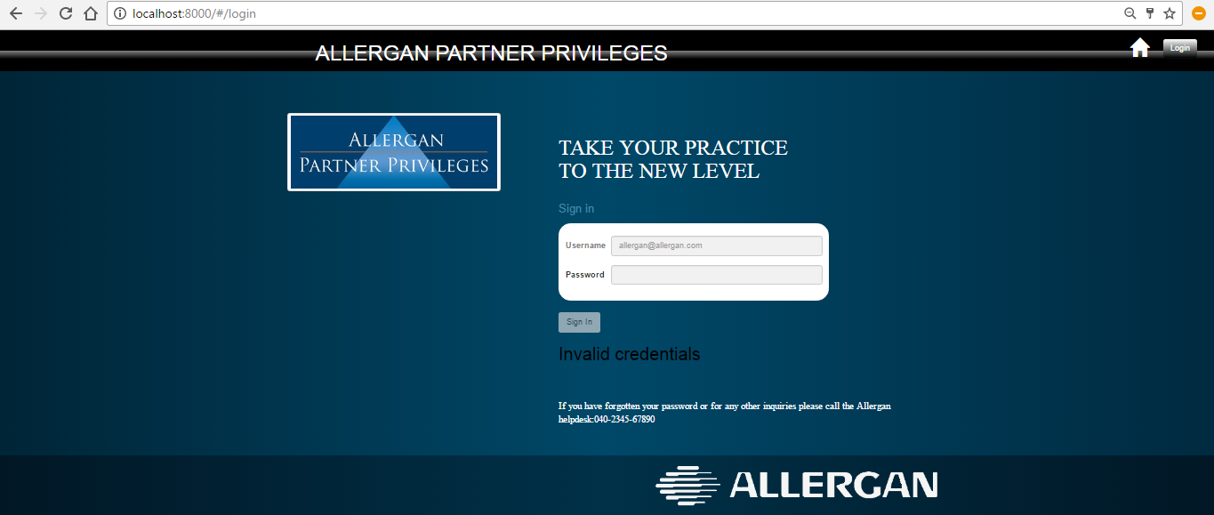

1. **ON SUCCESSFUL LOGIN :** *The users list of accounts based on different levels is displayed.*

Functionalities:

* *Home: The page stays in the same page (profile page).*
* *Logout: The page gets redirected to the home page.*
* *Search: The user can search the accounts.*
* *Sort: The user can sort based on the account level.*
* *Profile: User is able to view his/her profile and also can edit their profile.*

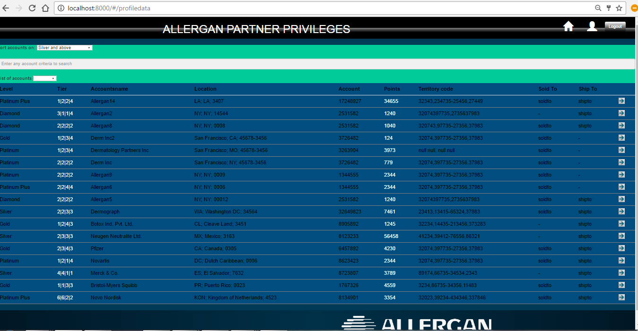

1. **Profile Page:** *This page appears on click of the profile button on the Accounts page. The user’s details will be displayed.*

Functionalities:

* *Search: The user can search.*
* *Home: The page is redirected to the users account page.*
* *Logout: The page gets redirected to the home page.*

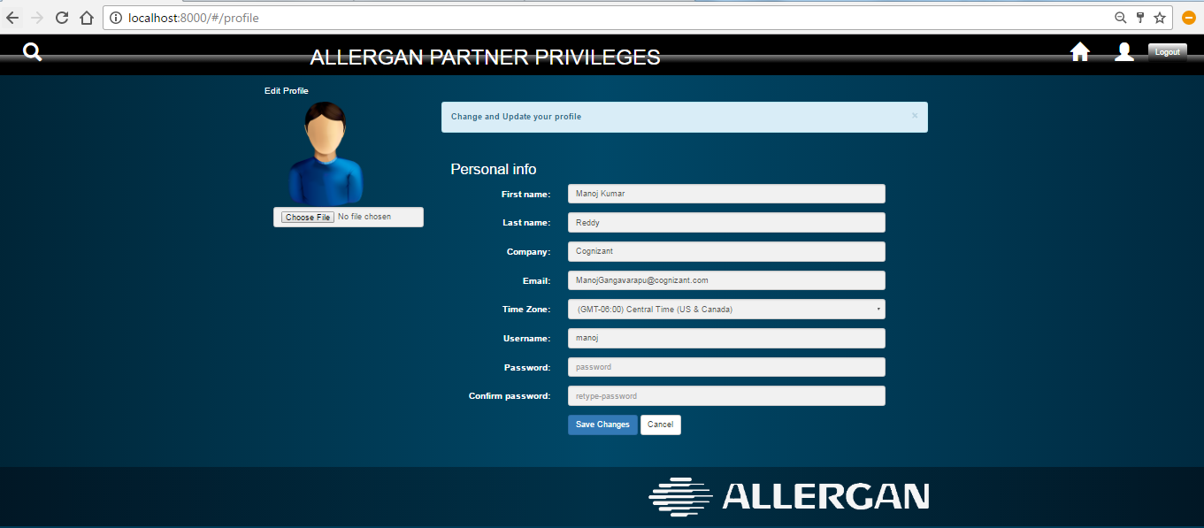

1. Levels : *On click of the arrow button shown in the accounts page, we get the account details for a particular account supported by graphs based on calculations of the past and present performances.*

Functionalities:

* *Home: The page is redirected to the accounts page.*
* *Logout: The page gets redirected to the home page.*
* *Profile: User is able to view his/her profile and also can edit their profile.*

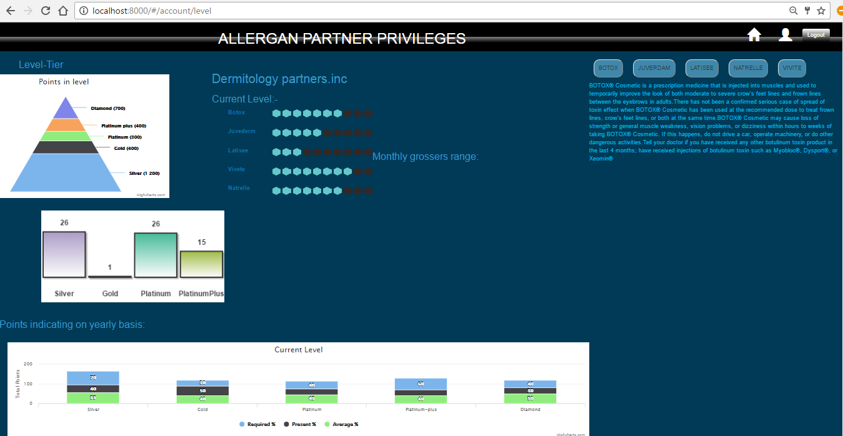

*The user can navigate to different pages using the navigation bar . Also the user can logout on click of the logout button.*

**Flowchart Representation :**

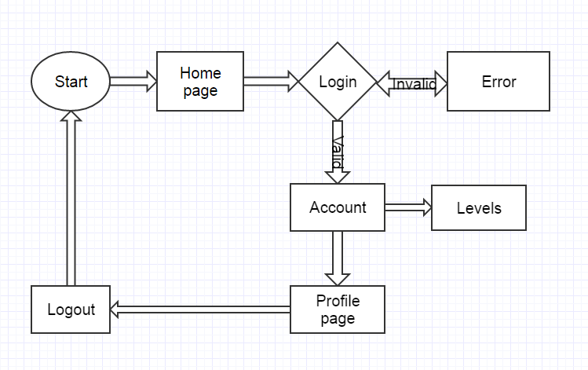

**Sequence Diagram :**

